CYBERSECURITY LAB REPORT: VIRTUAL NETWORK & FTP EXPLOITATION
Student Name: Paulson k Babu
Date: January 31, 2026
Lab Environment: Kali Linux (Attacker) & Ubuntu (Target Server)

1. Executive Summary
In this lab, a private virtual network was created to simulate a real-world client-server environment. An Ubuntu machine was configured as an FTP file server using vsftpd, while a Kali Linux machine acted as the client. Connectivity, authentication, file transfer, and troubleshooting steps were successfully performed.

2. Objectives
- Establish a bridged network connection between two virtual machines.
- Install and configure the vsftpd service on Ubuntu.
- Modify system permissions to allow remote file uploads.
- Monitor system behavior and logs for connection attempts.

3. Technical Procedures & Commands
Establish a bridged network connection between two virtual machines.

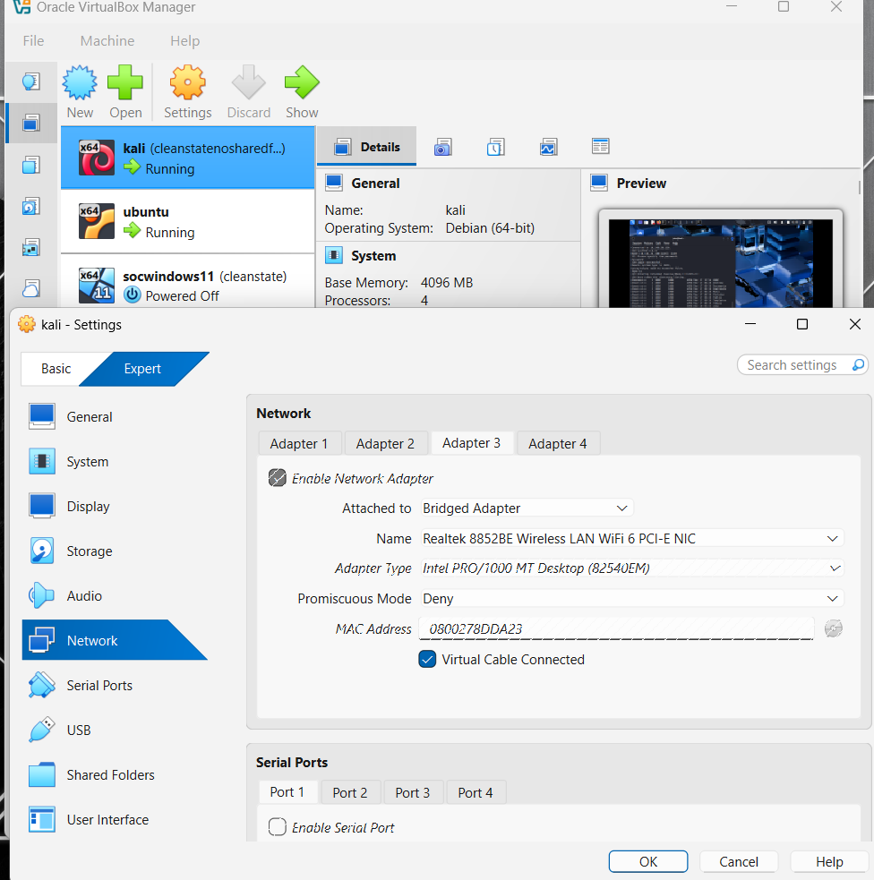

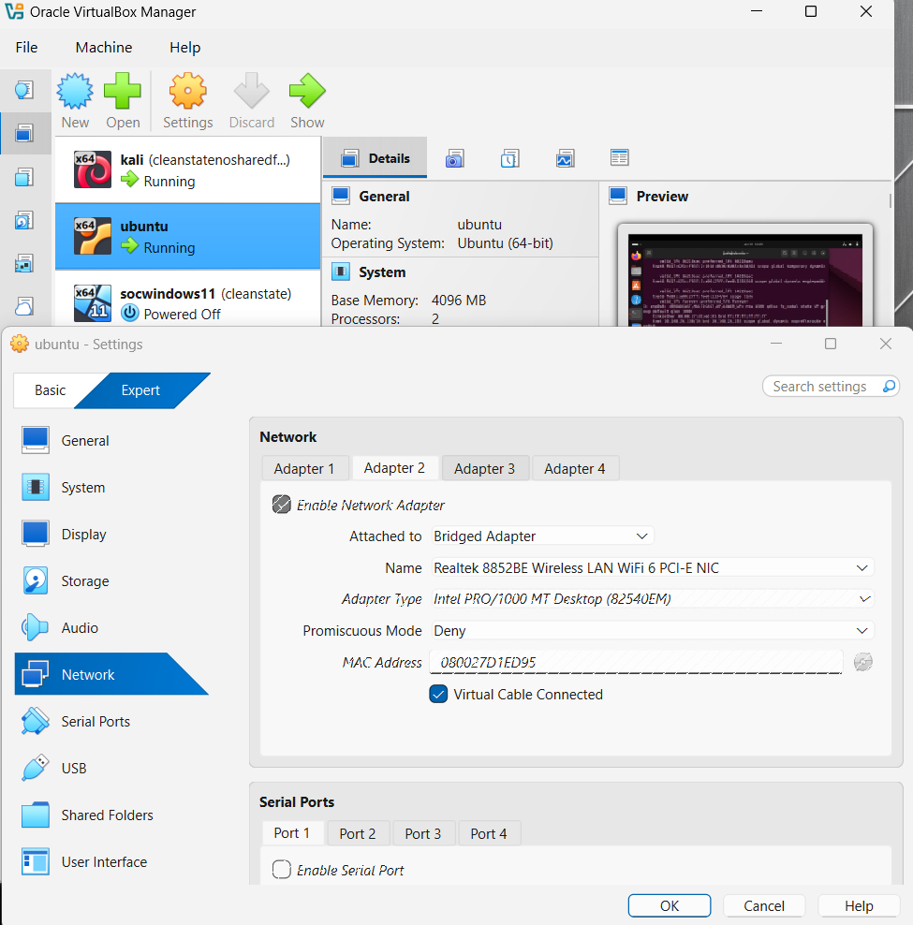

Phase A: Setting up the Server (Ubuntu)
The Ubuntu system was prepared to listen for incoming FTP connections.
- Install vsftpd service:
sudo apt install vsftpd
- Start the FTP service:
sudo systemctl start vsftpd
- Verify IP address:
ip addr
- Allow FTP through firewall:
sudo ufw allow 21/tcp
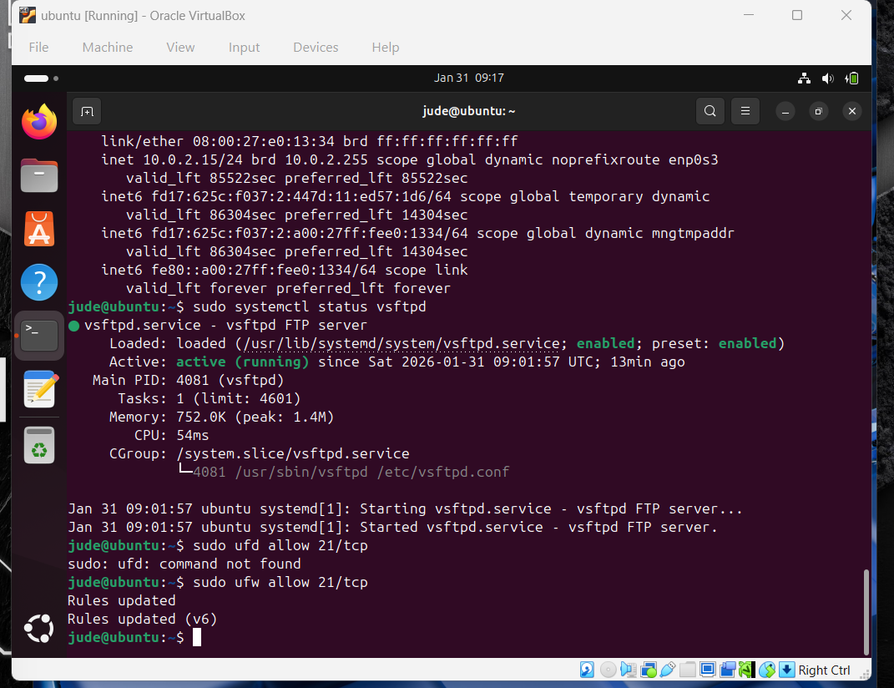

Phase B: Configuring Permissions
Server configuration was modified to allow file uploads from remote clients.
- Edit configuration file:
sudo nano /etc/vsftpd.conf
- Enable file writing by setting:
write_enable=YES
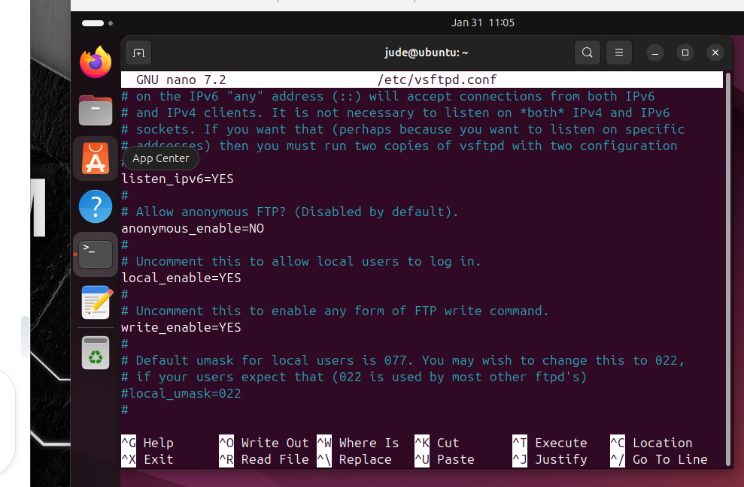
- Restart FTP service:
sudo systemctl restart vsftpd

Phase C: Connecting from Kali Linux
The Kali Linux machine was used to connect and upload files to the Ubuntu server.
- Test connectivity:
ping <Ubuntu_IP>
- Connect via FTP:
ftp <Ubuntu_IP>
- Upload file:
put secret.txt
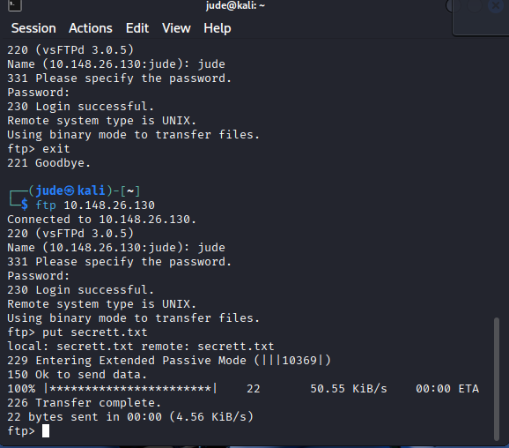
Evidence of FTP File Upload & Log Monitoring

- Monitoring /var/log/vsftpd.log:
Sudo tail -f /var/log/vsftpd.log
- Successful client connections
- Authentication events
- Confirmed file upload from Kali Linux → Ubuntu

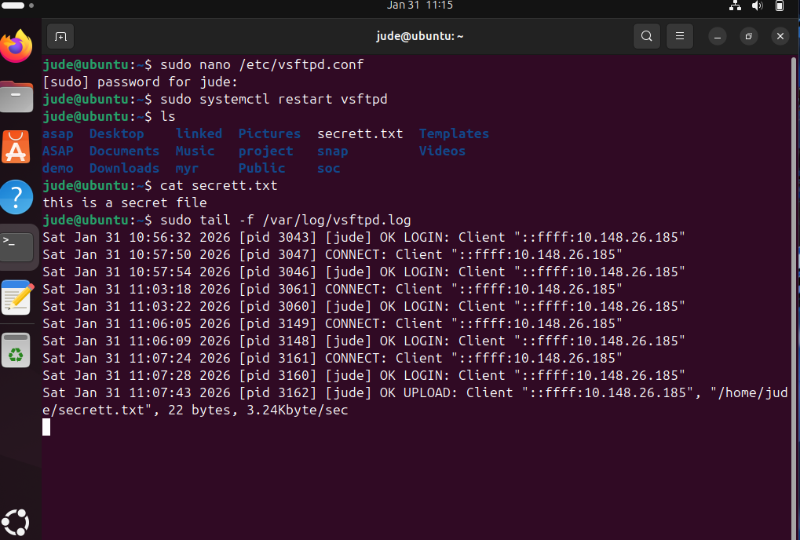

4. Troubleshooting Log
- Connection Refused – Resolved by ensuring the vsftpd service was running.
- Network Invisibility – Fixed by switching VM networking from NAT to Bridged Adapter and renewing IP using dhclient.
- Upload Denied – Solved by enabling write permissions in vsftpd configuration.

5. Conclusion
This lab demonstrated how data moves across a network and emphasized the importance of layered security. Proper network configuration, service availability, firewall rules, and permission management are all critical for securing real-world servers.

